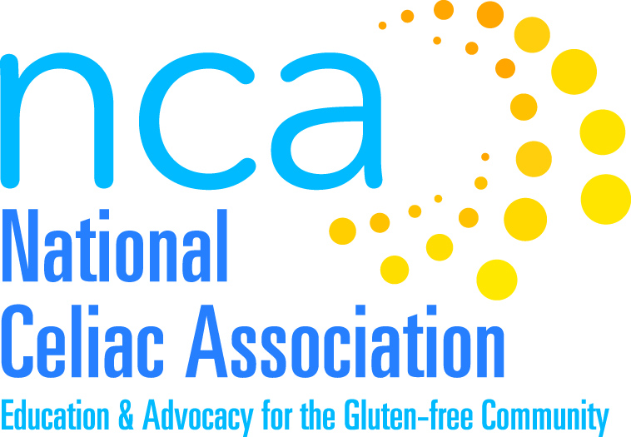

Application to become a National Celiac Association (NCA) Chapter

The National Celiac Association (NCA) remains dedicated to its mission of support, education, and advocacy for individuals with celiac disease, their families and communities across the nation. Our grass roots approach hasn’t changed since 1993 when we began this journey. We are here for the primary goal of serving and collaborating with the celiac community. It is our passion and our mission. And we are honored that you wish to take the journey with us.

A. Name of your organization: NCA Tennessee (NCAT)
Is your group still active? __yes, formerly the CSA Nashville/Middle Tennessee Celiac Chapter # 76

B. Leadership:
1. Name of present leader Carol Ann Baily, Chair
2. How long have you been a group? 25 years When did you begin? 1992

3. How many board members do you have? List members of your board and what positions they hold:

Carol Ann Baily, Chair

Jack McFadden, Secretary

Alice Johnson, Treasurer

Cara Richardson, Newly Diagnosed Coordinator

Cheryl Chamberlain, Past Chair

Dr. Craig Wierum, Physician Consultant

C. Membership in your group:
1. How many members do you have in your group? ___________68______________________

2. Do you collect dues? yes If so what do you charge each year? $20

D. Events:
1. How many events do you have each year? ___our November holiday potluck is our biggest event of the year_____________________________________

2. What kinds of events do you hold?__We sponsor a MeetUp group called the Nashville Gluten Free Dinner Club. Approximately every two months a group goes to dinner at a local restaurant that prepares gluten free dishes from their menu for us._____We sometimes have a mid-summer pool party with potluck; we used to have a cookie decorating and cookie exchange party in early December, but haven’t the last two years.____________________

3. How often do you meet? ____We meet in February, April, September and November __

4. How many people attend each event? _______Dinners 8-16; Meetings 20 - 40_______________

5. Do you charge for events? _____no_____ How much per person? ____________________

6. Do you hold any fundraisers? ___yes__ If so, how many and what are they? ____
________once a year, we have had a silent auction of gift baskets_______Several years ago we had a big awareness walk, the Boot Scootin’ Walk Against Gluten, but there is no interest in that event at this time_____________

7. How much do you raise at your fundraisers? _____less that $200________________

E. Educational material:
Does your group have a newsletter, website or other educational material? Please explain and attach a copy if you can. _________We have a website, a Facebook page, a Meetup Gluten-Free Dinner Club page, and we email out a newsletter to our members prior to each meeting._All can be accessed through our website: nashvilleceliacs.org_

F. Finances:
1. Do you have any salaried staff? ___no____ If yes, how many? _____________________

2. What is your total revenue in a year? ____average over the past three years_____ $2,650.00_____________________

3. What are the sources of your revenue (list % from each type of revenue)?

_________Donations 34%__________________________________________

__________Membership Dues 28%________________________________

__________Special Event Fund Raising 28%______________________

4. What are your total expenses in a year? ________$2664.39_________________

5. What were your net assets or fund balance at the end of December of last year?

_____________$822.51_______________

G. Insurance:
1. Do you need NCA to provide your group with an insurance policy to cover your events?

Yes _____________ No_____________ Not at this time

2. If yes, what events are they? Please include dates, title, and a brief description:

a. ________Since we have not had big public events recently, we do not think we need insurance at this time. However, if we were to do a big public fund raiser such as the walk that we did about 10 years ago, we would need insurance for such an event.

b. ________________________________________________________________________________________

c.__________________________________________________________________________________________

d._______________________________________________________________________________________

H. Legal Status and Governance Documents:
1. Does your group have existing by-laws? ____yes_____ If yes, please include a copy with this application. We have re-written our CSA chapter by-laws. We enclosed the proposed NCA Tennessee by-laws which have been approved by the Board, but not yet brought to the membership for a vote. We will do that when we are officially an NCA chapter.

2. Has your group registered with your state Attorney General’s office or other state charity official? _______not at this time because we haven’t been raising enough funds___

3. Are you an incorporated or other type of legal entity? _We have submitted our incorporation paperwork with Tennessee____________ If so, include a copy of the organizing documents, such as Articles or Certificate of Organization or Incorporation.

4. Do you have a 501(c){3} status? ______no_____ If so, include a copy of the IRS Letter of Determination or state why you don’t have such a letter. We had an IRS letter through CSA which we understand was not really legal, but that is what we have used for years.

5. If you do have a 501(c){3} status, do you know whether you are a public charity or a private foundation? (Choose one)

Please explain: ____________________________________________________________________________

6. NCA intends to apply for a group exemption under Section 501(c){3}. Do you wish to be under NCA’s group exemption? yes
www.nationalceliac.org • 1.888.4.CELIAC

